**GENERAL HUMAN BIOLOGY – YEAR 12**

TASK 9 – INFECTIOUS DISEASE TEST

**NAME: ________________________________________ WEIGHTING: 10%**

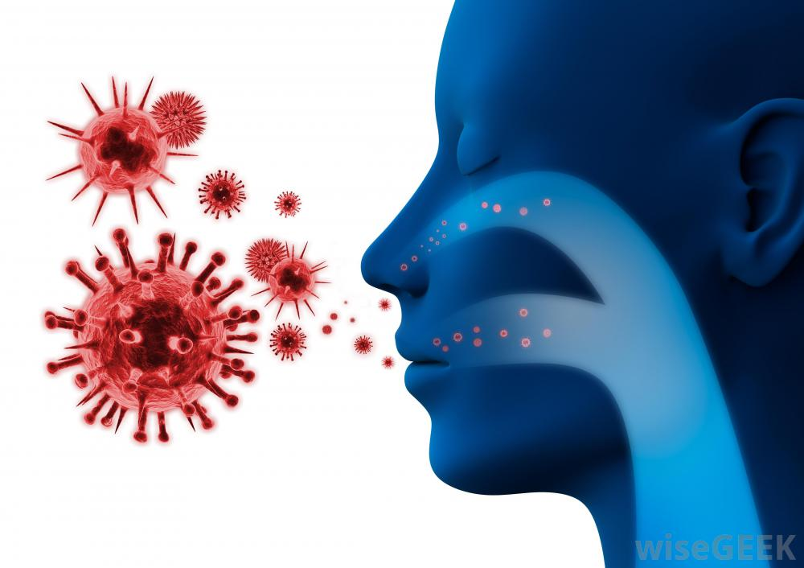

|  |  |
| --- | --- |
| Multiple Choice | /7 |
| Short Answer | /41 |
| **TOTAL** | **/48** |

***MULTIPLE CHOICE (7 MARKS)***

1. Which of the following is an example of a disease spreading by direct contact?
   1. Sneezing
   2. Coughing
   3. Kissing
   4. Sweating
2. Which of the following is a transmissible (passed from host to host) disease?
   1. Scurvy
   2. Food poisoning
   3. Diabetes
   4. Cancer
3. Pathogens are __________.
   1. Disease causing microbes or germs
   2. Non disease causing and are beneficial
   3. A natural part of the body
   4. Always treated with antibiotics
4. Sam is preparing wooden beams when he receives a nasty splinter. Her immune system would start by causing what to occur at the sight of injury?
   1. Mast cells release histamine
   2. The capillaries become leaky to grant phagocytes access to the invading pathogen
   3. Nothing happens at the start because the body does not recognise the invading pathogens
   4. Clotting in the injury area occurs
5. James has developed flu, and his throat is very sore. Which of the following cells is responsible for destroying the cells of his throat because they have become infected by a virus?
   1. B Cells
   2. Phagocytes
   3. Natural Killer Cells
   4. Mast Cells
6. Which of the following will not efficiently prevent the transmission of a disease?
   1. Quarantine
   2. Immunisation
   3. Medications that disrupt pathogen life cycle
   4. Anti-histamines
7. When chefs wash their hands after going to the toilet, they:
   1. reduce the likelihood of infecting their customers through airborne transmission
   2. do not need soap as the water alone washes away pathogens
   3. reduce the likelihood of infecting their customers through bodily fluids
   4. lower the chance of their customers contracting food poisoning

***SHORT ANSWER (41 MARKS)***

1. Define ‘infectious disease’. (1 mark)

___________________________________________________________________________________ ___________________________________________________________________________________

1. Draw a line to match the pathogens with their example (2 marks)

|  |  |  |
| --- | --- | --- |
| Bacteria |  | Tinea/Athlete’s Foot |
| Virus |  | Malaria |
| Parasite |  | Ross River |
| Fungi |  | Food Poisoning |

1. Parasites rarely kill their host. Suggest a possible reason why. (2 marks)

_____________________________________________________________________________________ ______________________________________________________________________________________________________________________________________________________________________________________________________________________________________________________________

1. Sarah recently went on holiday to Sudan to visit her Sudanese friend. While there, Sarah was taken to lots of places by her friend, and she ate and drank the same as her friend, though it was her first time eating and drinking this cuisine and she became ill. The food and water were not contaminated, and Sarah has no intolerances. Suggest a possible explanation as to why Sarah fell ill but her friend didn’t.

(2 marks)

_____________________________________________________________________________________ __________________________________________________________________________________________________________________________________________________________________________

1. Describe four ways that a disease can be transmitted from one person to another. (4 marks)

_____________________________________________________________________________________ ___________________________________________________________________________________________________________________________________________________________________________________________________________________________________________________________________________________________________________________________________________________ _______________________________________________________________________________________________________________________________________________________________________________________________________________________________________________________________

1. List two adaptations that bacteria have and explain why the enable entry to the human body. (4 marks)

_____________________________________________________________________________________ ___________________________________________________________________________________________________________________________________________________________________________________________________________________________________________________________________________________________________________________________________________________

1. A friend of yours is going to malaria-prone Nepal for leavers. In the space below, outline one recommendation you have to reduce your friends’ chance of contracting malaria, and explain why it will help. (2 marks)

_____________________________________________________________________________________ ______________________________________________________________________________________________________________________________________________________________________________________________________________________________________________________________

1. Explain why patients in third-world hospitals are more prone to water-borne diseases than Australian patients. In your answer, address the differences in infrastructure, education and hygiene practises.

(3 marks)

_____________________________________________________________________________________ ______________________________________________________________________________________________________________________________________________________________________________________________________________________________________________________________

_____________________________________________________________________________________ __________________________________________________________________________________________________________________________________________________________________________

1. Josie was walking barefoot outside when she accidently stood on a dirty nail. The next day, the wound was red, hot, swollen and sore. Explain why Josie experienced each of these symptoms. (4 marks)

_____________________________________________________________________________________ ______________________________________________________________________________________________________________________________________________________________________________________________________________________________________________________________

_____________________________________________________________________________________ _______________________________________________________________________________________________________________________________________________________________________________________________________________________________________________________________

1. Explain how cilia and mucous membranes in your respiratory system work together to reduce your chance of becoming infected. (2 marks)

_____________________________________________________________________________________ ___________________________________________________________________________________________________________________________________________________________________________________________________________________________________________________________________________________________________________________________________________________ _____________________________________________________________________________________

1. 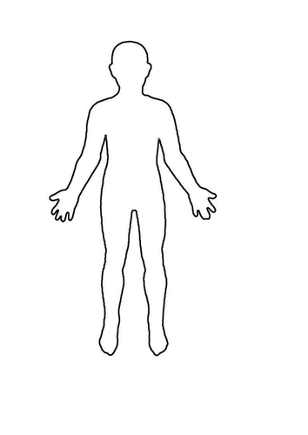In the space below, label three external defences, other than cilia and mucous membranes, that help to reduce your chance of contracting an infectious disease. (3 marks)
2. Compare antigens and antibodies. (2 marks)

_____________________________________________________________________________________ ______________________________________________________________________________________________________________________________________________________________________________________________________________________________________________________________

1. Explain what memory cells are, and how they enable a faster immune response when exposed to a pathogen. (2 marks)

_____________________________________________________________________________________ ___________________________________________________________________________________________________________________________________________________________________________________________________________________________________________________________________________________________________________________________________________________

1. Observe the graph below. Explain why antibodies are made more rapidly, and in greater numbers, during the secondary exposure. (2 marks)

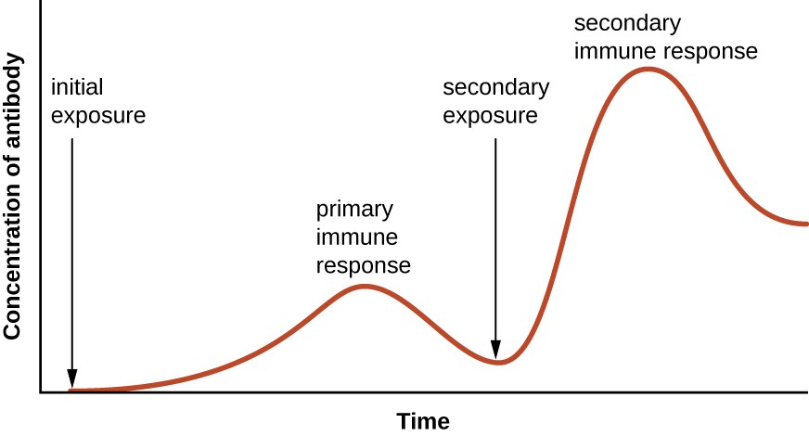_____________________________________________________________________________________ ______________________________________________________________________________________________________________________________________________________________________________________________________________________________________________________________

1. Compare and contrast the cell-mediated and antibody-mediated immune responses. (6 marks)

**Cell-Mediated Immune Response**

**Antibody-Mediated Immune Response**

***END OF TEST***